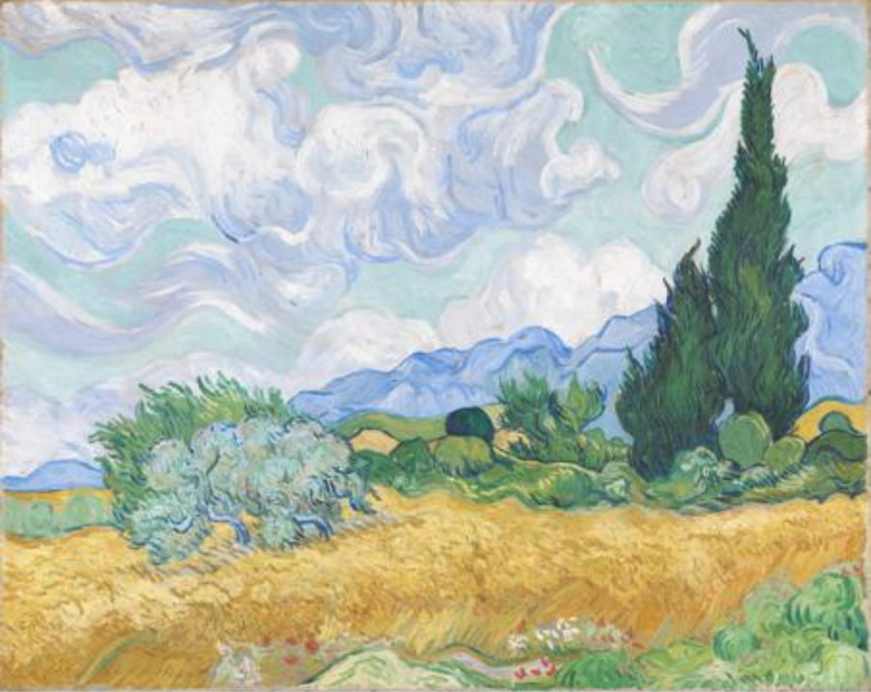

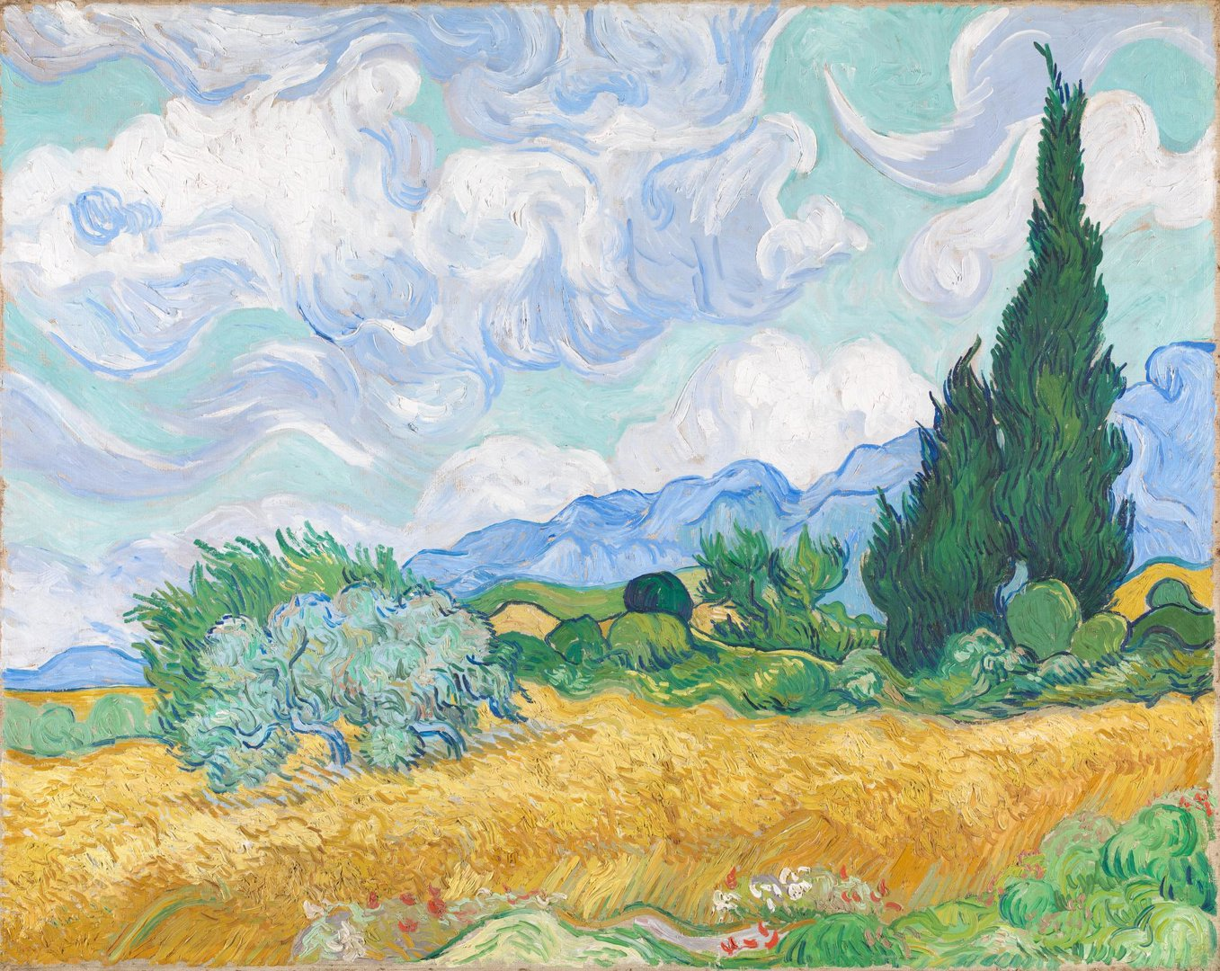

Lim Tze Peng

1. Street market sell

This black and white work by Lim Tze Peng depicts a bustling marketplace, full of vendors displaying their goods, and curious patrons who browse the stalls. Lim uses bold lines which articulate the defined forms of the umbrellas, people and the buildings in the background of the composition, while the rich tonal harmonies define the negative spaces through the blend of black and white shades over white. Light and dark modulate the contours of the artwork, creating a vibrant and energetic spirit that makes the scene come alive. Through the absence of colour, focus is instead placed on the stark beauty of Lim’s brushstrokes, rendering this scene of everyday life with dignity and a sense of nostalgia.

1. Coffeeshops at china town

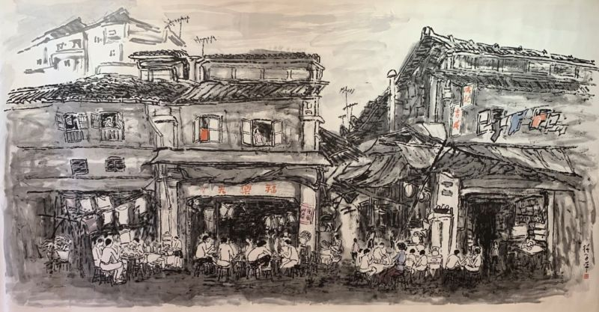

In this work, Lim Tze Peng depicts a street in Chinatown with various coffee shops, a frequent and familiar sight in old Singapore. Lim presents a picture that reflects the past and yet enlivens it with glimpses of life and motion. Intricate strokes derived from calligraphy and the use of classic ink wash imbue the image with gradients and tones that exude emotion. He renders the scene with exquisite detail, depicting the nuances of the facades of the shophouses as well as the various patrons. Lim’s use of negative space as a border imbue the work with a sense of nostalgia, reminding the viewer that this scene is one of a bygone era, and leaving them with further thoughts to ponder. The painting is testament to the far-ranging vision of the artist and his meticulous skill that merges with emotion in flowing strokes of ink.

1. Abundant Loads

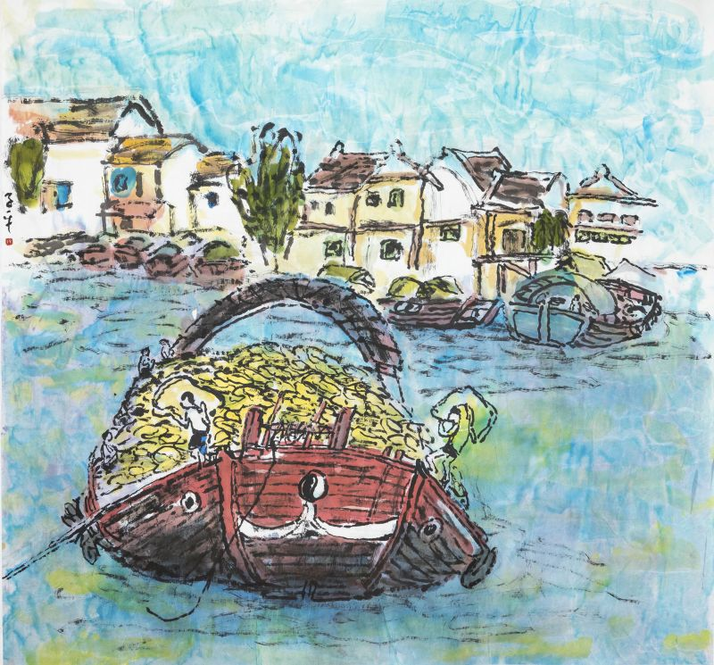

Abundant Loads is another addition to Lim Tze Peng's series of Singapore sceneries, capturing a scene by the river. An extremely vibrant work, Lim's use of clear, bright colours breathes new life into the banality of what would be a typical working day in industrialised Singapore. His brushstrokes are rough but delineate each figure promptly while leaving room for abstraction. With the rapid advancement into an era of technology and modernity, the landscapes of Singaporean communities have undergone massive change. Many times, this change occurs without much time to look back at our culture, to preserve, to reminisce. Lim Tze Peng's dynamic style is a sentimental call to a Singapore that has long gone, but remains conserved in its own unique way for us to look back upon fondly.

1. Bumboats by the Old River 2020

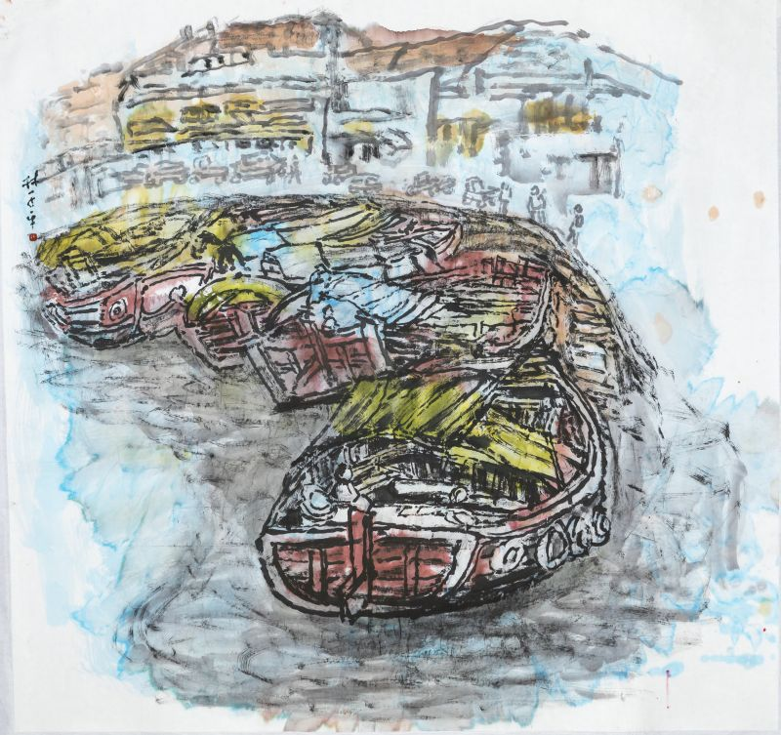

Lim Tze Peng is well-known for his scenes of the Singapore River - effectively capturing the lifeline of Singapore for over 150 years through vivid colour and rhythmic lines. The banks of Boat Quay contained warehouses and jetties, bumboats bore goods along the bustling waters affectionately termed ‘Mother River’- which were integral for developments in trade and economic growth. The changing landscape of the river mirrored the transition of the nation into a modern metropolis and Lim Tze Peng deems the river worthy of remembrance. His paintings preserve the memories of Singapore's heritage.

1. Hua Ji Roasted Delight 2020

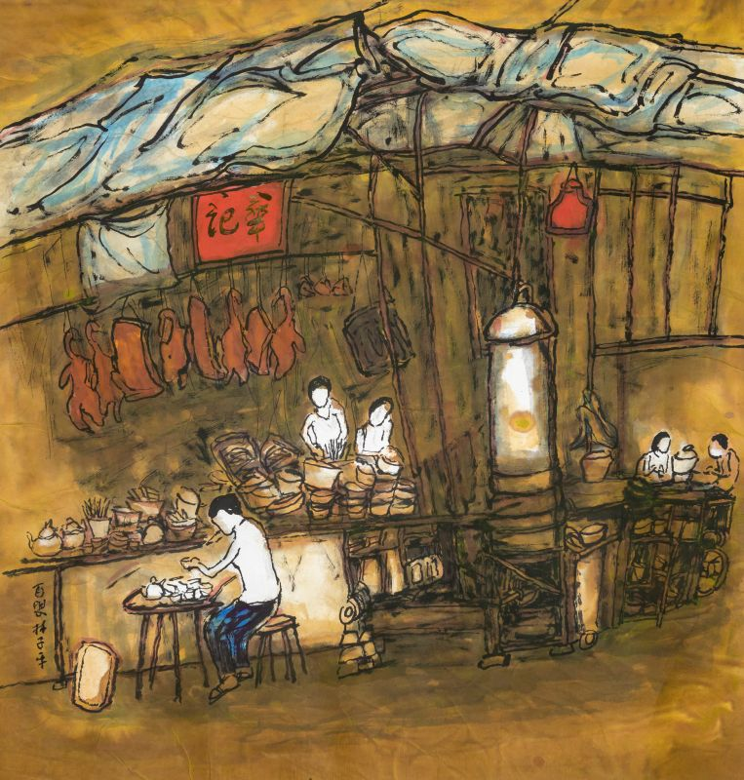

Painted with vibrant hues of ochres with highlights made in white, red and blue, this piece is another spirited addition to Lim Tze Peng's array of Singapore scenes. The visuals of a roasted meat store is still familiar to us today, echoed by the vision of roasted meat displayed from its rafters as hawkers toil away. However, the distinctive elements of the past are highlighted within its details - a small tea set accompanying a patron, stacked piles of cutlery, and an oil lamp emanating a red glow from its perch beneath the blue tarp ceiling. Each character is highlighted in white, framed in thin strokes and untextured compared to their surroundings. With the rapid advancement into an era of technology and modernity, the landscapes of Singaporean communities have undergone massive change. Many times, this change occurs without much time to look back at our culture, to preserve, to reminisce. Lim Tze Peng's dynamic style is a sentimental call to a Singapore that has long gone, but remains conserved in its own unique way for us to look back upon fondly.

WU SHUNING

1. 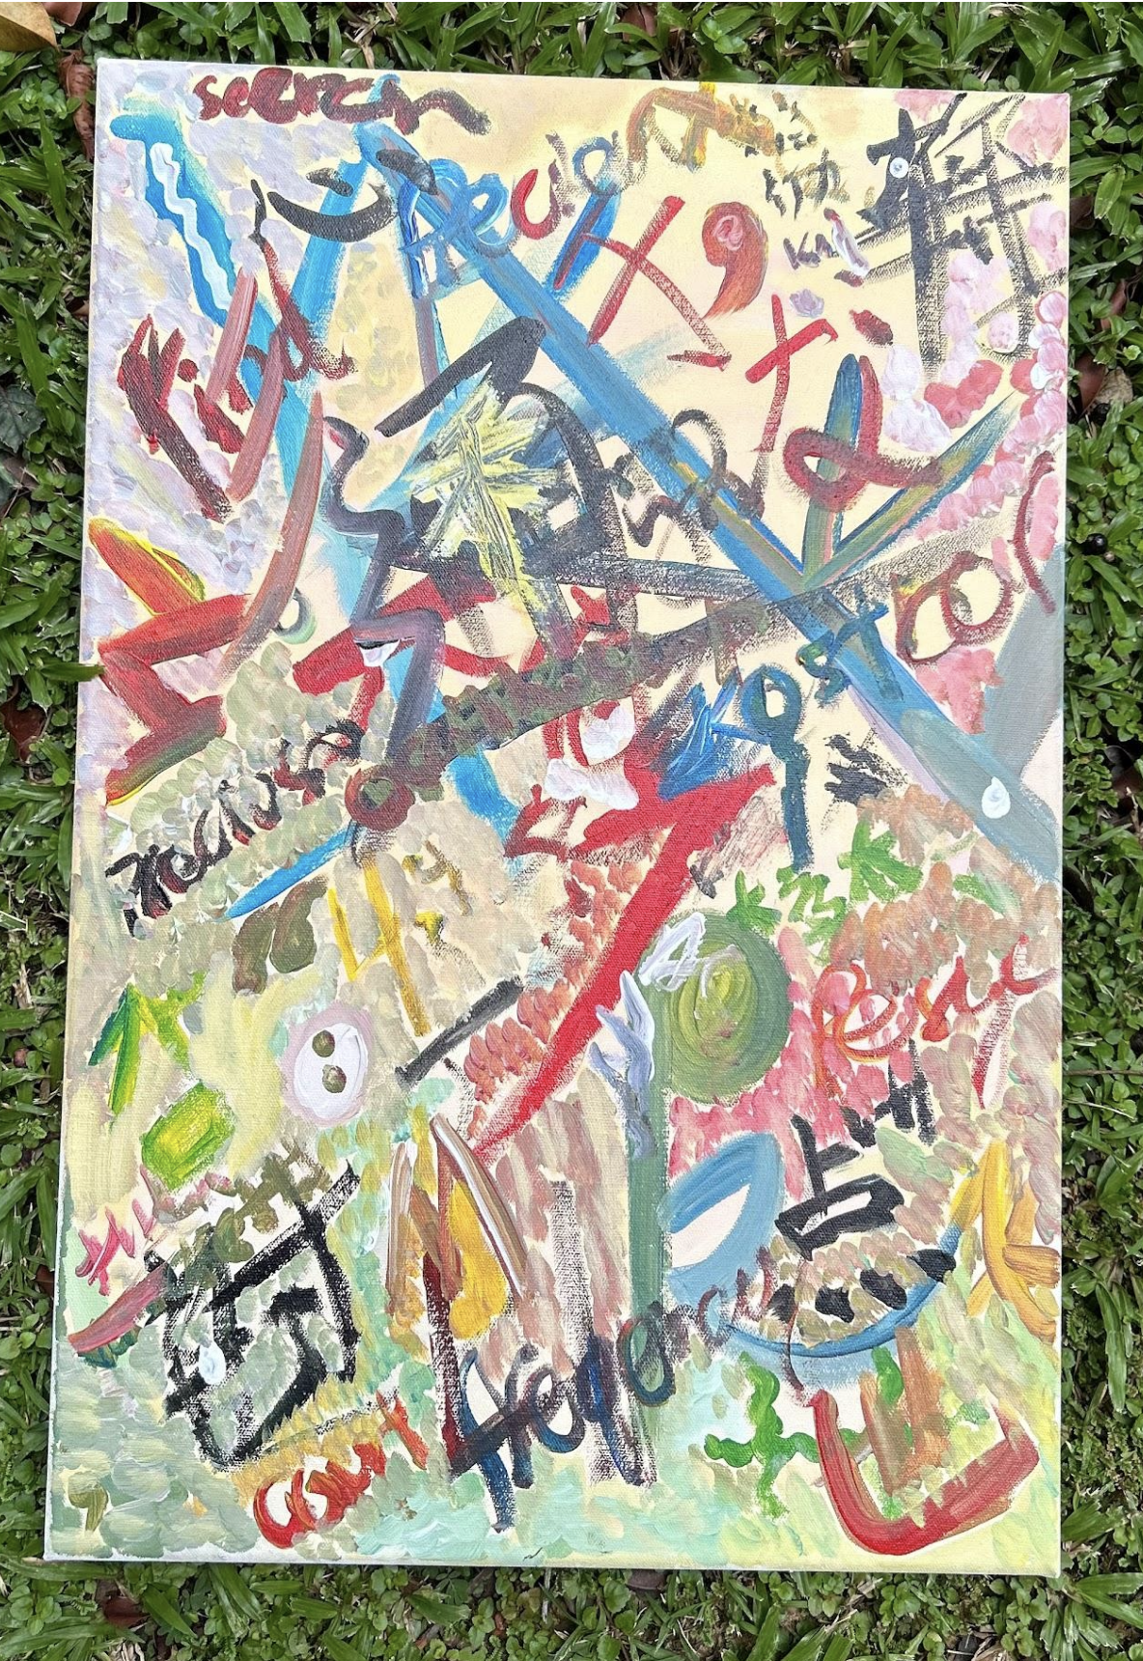
2. 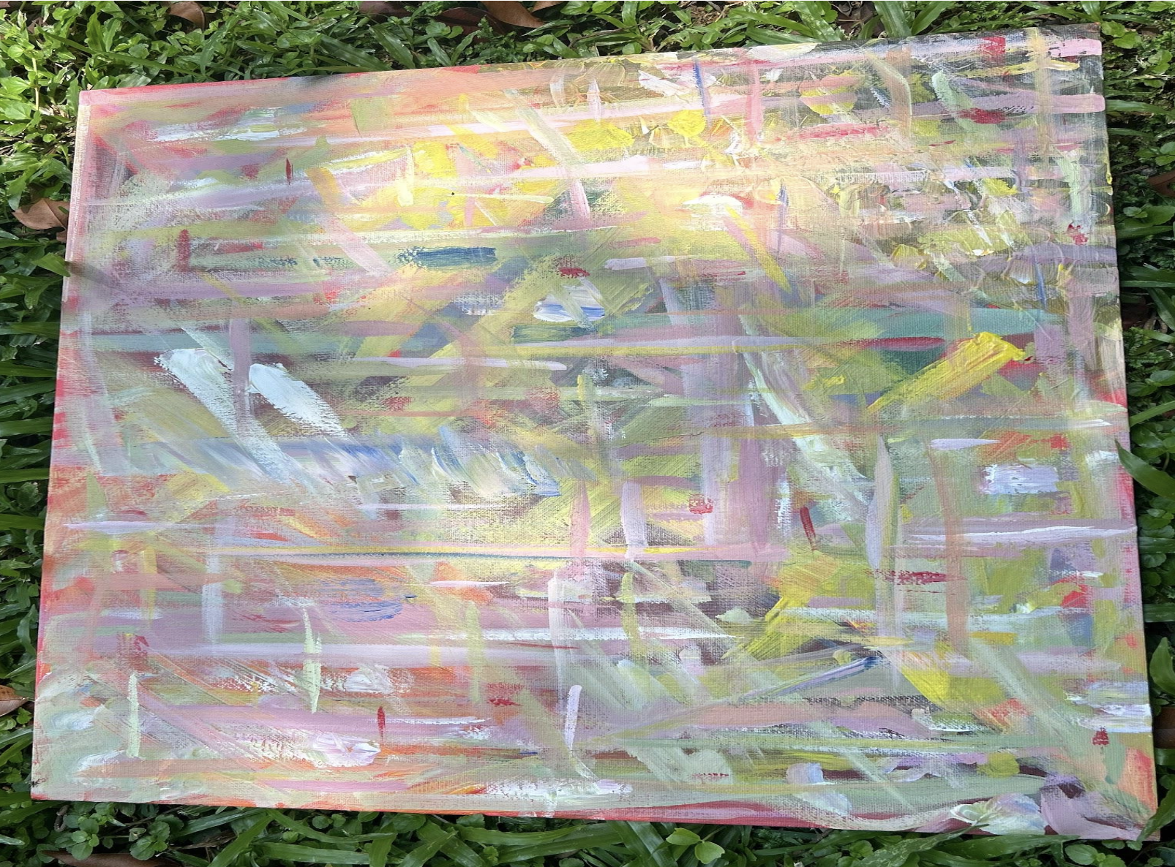
3. 